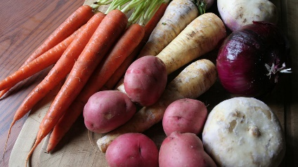
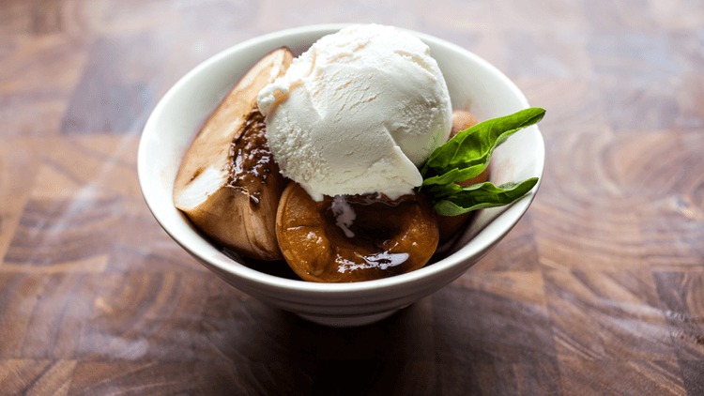
August 2023 SNAP-Ed Newsletter and Recipes
Fayette County Community Action Agency
The Nutrition Education Program, NEP

Roasted Root Vegetables  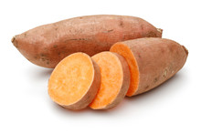  “Even picky eaters can enjoy this fresh spin on home fries”.  Ready In: 40 minutes Serves: 6 Serving Size: 1 cup  Ingredients  - Nonstick Cooking Spray 2 beets  - 6 carrots 2 sweet potatoes  - 1 tablespoon thyme fresh, chopped or 1 teaspoon dried thyme  - 1 tablespoon fresh parsley chopped or 1 teaspoon parsley dried  - ½ teaspoon salt (feel free to use less)  - 1 ½ tablespoons vegetable oil  Directions  1. Preheat oven to 450 degrees F. Line 2 baking sheets with aluminum foil and lightly spray with nonstick cooking spray. Set aside.  2. Peel beets, carrots, and sweet potatoes, and cut each one lengthwise into ½-inch slices.  3. In a bowl, mix thyme, parsley, and salt.  4. In a bowl, toss vegetables with vegetable oil. Sprinkle in mixed herbs. Toss again.  5. Spread vegetables in a single layer on prepared baking sheets. Bake until vegetables are tender and golden, turning occasionally with tongs, 20 to 25 minutes.  6. Transfer to a dish and serve.  Utilize root vegetables found in this month’s product distribution box! | Roasted Stone Fruit with Ice Cream  “Summer is stone fruit season. Make this yummy treat to cool down after a warm day.”  Ready In: 30 minutes  Serves: 4  Serving Size: ½ cup  Ingredients  - 2 plums cut in half and pitted  - 2 peaches cut in half and pitted  - 2 nectarines cut in half and pitted  - ½ cup balsamic vinegar  - Salt  - Black pepper  - 1-pint French vanilla ice cream  Directions  1. Preheat oven to 350-degree F.  2. Place the fruit in a small baking dish. Drizzle with balsamic vinegar and season with a little salt and pepper.  3. Transfer to the oven and roast for 15 to 20 minutes depending on how ripe your fruit is.  4. Remove from the oven and divide between four dessert bowls, drizzle with any of balsamic vinegar that is in the baking dish.  5. Top each bowl with a scoop of ice cream.  Apricots can be used in place of any of the fruits listed!  Check out the back of this newsletter to learn more about stone fruit!

Recipe Sources for Roasted Root Vegetables and Roasted Stone Fruit with Ice Cream:
Roasted Root Vegetables: https://eatfresh.org/recipe/side-dish/roasted-root-vegetables
Roasted Stone Fruit with Ice Cream: https://eatfresh.org/recipe/desserts/roasted-stone-fruit-ice-cream
Uniontown Area Farmers Markets, Nutrition Program Vouchers, and Food Bank Information
The Food Bank will be distributing fresh and canned produce which can be used in both recipes featured in this newsletter. Senior Farmers Market Vouchers are now available. These vouchers may be used at local, PA Preferred farmers markets to purchase locally grown fruits and vegetables. Listed below you will find farms and farmers market locations accepting Senior Farmers Market Vouchers, WIC Farmers Market Vouchers, and the EBT SNAP Card.
Duda’s Farmers Market Stands: Monday-Friday 10am to 5pm, weekends 10am to 4pm through October 2023. Duda’s Farmers Market Stands can be found at multiple locations throughout Fayette County.
His & Hers Farm: Located at the Uniontown Farmers and Producers Market held in the Bailey Park parking lot Saturdays from 9am to 1pm through September 9, 2023, and Storey Square Farmers Market on Thursdays from 5:30pm to 7pm through August 24, 2023. *Other farmers and farmers markets may accept vouchers and the EBT SNAP Card. Inquire with local farmers at the Uniontown Farmers and Producers Market and the Storey Square Farmers Market to find out more!
Learn More About: Stone Fruit
Stone Fruit inlcudes peaches, nectarines, plums, apricots, and cherries. These fruits are referred to as “stone fruits” because the seed is very large and hard, and they have a soft, juicy flesh. Stone fruits are in-season during the summer and are much more expensive and less tasty in the off-months.
Buy It: Choose stone fruit that doesn’t contain bruises or soft spots. Delicious fruit may be firm when you buy it, but it will ripen at home.
Store It: Let stone fruit ripen on the counter. Once fruit is ripe, store in the refrigerator for one week.
Cook It: Stone fruit can be eaten raw. Try roasting stone fruit in the oven at 350 degrees F for 15-20 minutes and top with cinnamon and vanilla ice cream for a delicious dessert.
Why It’s Great: Stone fruit contains the following: Vitamin A, which keeps our eyes working, our immune system strong, and our cells growing. Vitamin C keeps our immune systems strong and helps our bodies heal quickly. Fiber helps with healthy digestion and keeps us feeling full. Potassium, a type of electrolyte, helps build muscles and keeps your heart healthy.
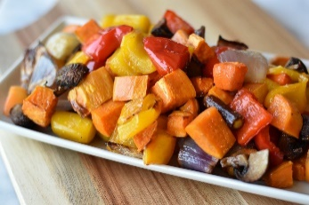
Why are roasting and grilling our foods a good idea? Roasting and grilling are healthy ways to prepare not only the recipes featured in this newsletter, but also beef, poultry, seafood, and other vegetables like corn on the cob. These methods of cooking provide low-fat alternatives to frying and allow you to experiment with different spices and seasonings on the grill; all while taking advantage of warmer days outside. Plus, the taste they give our food is summer on a plate!

This institution is an equal opportunity provider. This material was funded by USDA’s Supplemental Nutrition Assistance Program (SNAP) through the PA Department of Human Services (DHS). Featured information found in this newsletter is provided by the SNAP-Ed funded, New York State Department of Health’s Just Say Yes Curriculum, https://www.myplate.gov/eat-healthy/fruits, https://www.myplate.gov/eat-healthy/vegetables, and https://eatfresh.org. To learn how you can participate in a SNAP-Ed class via in-person, telephone, or online, please contact Gretchen Billy, SNAP-Ed Project Manager, at (724) 430-6428 or email gbilly@fccaa.org. Or contact Rosemarie LeDonne, SNAP-Ed Nutrition Educator, at (724) 430-6431 or email rledonne@fccaa.org.

