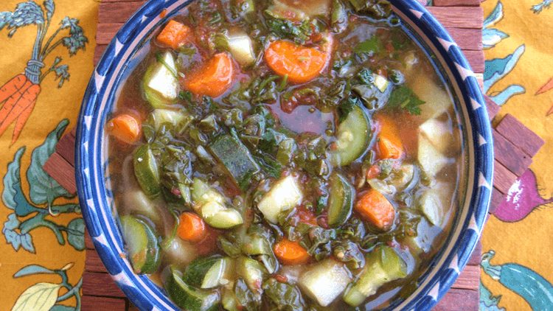
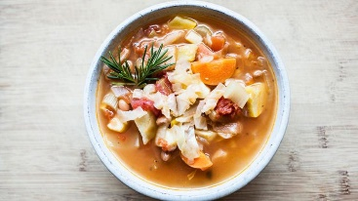
November 2022 SNAP-Ed Newsletter and Recipe
Fayette County Community Action Agency
The Nutrition Education Program, NEP
Featured information on *Savory Soups- Reducing Sodium found on the back of this newsletter!

Hearty Vegetable Soup  “This is a delicious way to use up bits of vegetables and herbs you have in the fridge or freezer, even the ones that are wilted.”  Makes:4 servings  Serving Size: 2 cups  Ready In: 40 minutes  Ingredients  3 tablespoons olive oil  1 onion large, diced  1 teaspoon cumin  2 potatoes medium, diced  3 tomatoes chopped  4 cups of vegetables, such as carrots, zucchini, yellow squash, bell pepper, celery, asparagus, corn, peas, okra, green beans, spinach, kale, mushrooms, cabbage, or lima beans; chopped, fresh, frozen, or canned  4 cups vegetable broth  2 cups water  Salt to taste (or, omit salt; replace with onion or garlic powder to flavor)  Black pepper to taste  ½ lemon juiced  Directions  1. In a large stockpot, sauté the onion and celery (if using) in olive oil until golden. Add garlic and cumin and cook a minute longer.  2. Add the potatoes (and any root vegetables, such as carrots), tomatoes, broth, and water. Bring to a boil and simmer until the potatoes are tender.  3. Add the other vegetables and simmer until everything is soft.  4. Stir in lemon juice. Season with salt and pepper, to taste. | Recipe Notes, Ideas, and Substitutes  - What will I need to make Hearty Vegetable Soup? You’ll need a pot, a large stockpot, and a sharp knife.  - Chef’s tips for Hearty Vegetable Soup…Fresh tomatoes can be substituted with one (14.5-oz.) can of diced tomatoes. Try at least three different kinds of vegetables in this recipe! Visit https://www.myplate.gov to learn more about vegetables, health benefits, and colors of good health.  - Substitutes…Remember, all vegetables count towards your daily recommended intake (3 cups); meaning, you can utilize fresh, frozen, or canned vegetables. Asparagus will be provided in this month’s food distribution box, along with canned corn, canned green beans, canned white potatoes, and canned sweet potatoes. All items can be used in the Hearty Vegetable Soup recipe and can also assist in stretching your food dollars when shopping for additional ingredients and weekly meals. Omit salt (as the Hearty Vegetable Soup recipe calls for), and include onion powder, garlic powder, or both. Omitting salt will reduce your sodium intake, and onion/garlic powder will flavor your soup while keeping it healthy and salt free!  - Healthy soup recipes…For more healthy soup recipes and ideas utilizing multiple types of colorful vegetables, visit https://www.myplate.gov, or https://eatfresh.org.

Recipe Source for Hearty Vegetable Soup:
https://eatfresh.org/recipe/soups/hearty-vegetable-soup

Savory Soups- Reducing Sodium!
Seniors, especially, are at risk for high blood pressure (hypertension) due to age, stiffening of arteries, and high dietary sources of sodium, which increases blood volume, and increases the risk of heart disease and stroke. Heart disease is the leading cause of death in the United States. Did you know that on average, the higher the person’s salt intake, the higher their blood pressure? How can you gain the skills and confidence needed to make more informed decisions and prepare or order more healthful, lower sodium foods to meet your dietary needs? Let’s find out!

First: Let’s identify high sources of dietary sodium…
Where does most of the sodium in our diet come from? Almost all (over 80%) of the sodium we eat comes from salt added to packaged, processed, and restaurant/fast foods. Only a small amount of sodium comes from salt added in home cooking or at the table. Processed or cured meats, such as bacon, ham, and hot dogs, quick-cooking rice mixes and noodles, and high sodium snacks like chips, crackers, pretzels, and salted nuts are examples of high sodium foods.
Second: Remember to always read the Nutrition Facts Label…
How do you know how much sodium is in foods you buy? Many foods pack a lot more sodium than you think. Always read the Nutrition Facts Label and look for foods with less than 5% of sodium per serving.
Third: Keeping salt low in your foods…
Important steps you can take to keep salt low in your foods include slowly cutting back on the amount of salt added when cooking until you are using very little or none at all, avoid adding salt to water when cooking beans, rice, pasta, and vegetables, rinsing all canned beans and vegetables, and cooking more at home. The more you cook at home using fresh fruits and vegetables, the less sodium you’ll eat! Omit salt and flavor foods by using vinegar, lemon, orange zest, low-sodium soy sauce, spices, and fresh or dried herbs (you can create your own salt-free spice blends using your favorite spices).

Savory soups, cooked at home, are an excellent way to gain your daily vegetable intake and add savory flavor without including salt! Below you’ll find instructions to savory soup favorites…

Cream of Vegetable Soups
Soup Base: ½ cup low-sodium chicken broth, 1 tablespoon chopped onion, 1/3 cup skim milk or canned evaporated skim milk.
Vegetable Variations:
Cream of Broccoli or Cauliflower Soup, add: 2 cups chopped broccoli or cauliflower and 1/8 teaspoon cayenne pepper.
Cream of Carrot Soup, add: 1 cup peeled, diced carrots, and 1/8 teaspoon nutmeg.
Cream of Sweet Potato Soup, add: 1 cup sweet potato, peeled and cubed, and 1/8 teaspoon cinnamon.
Combine chicken broth, onion, vegetable, and seasoning in a saucepan. Bring to a boil. Reduce heat, cover and simmer 10-15 minutes or until vegetables are tender. Pour into a blender or food processor. Add skim milk or light cream and blend until smooth. Serve hot or cold.

This institution is an equal opportunity provider. This material was funded by USDA’s Supplemental Nutrition Assistance Program (SNAP) through the PA Department of Human Services. Featured information on *Savory Soups- Reducing Sodium is provided by the SNAP-Ed funded, New York State Department of Health’s Just Say Yes Curriculum and Penn State Extension’s Seniors Eating Well Curriculum. To learn how you can participate in a SNAP-Ed class, please contact Gretchen Billy, Nutrition Education Program Project Manager, at (724) 437-6050 Ext. 3281 or email gbilly@fccaa.org.

