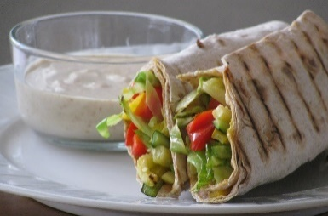
October 2022 SNAP-Ed Newsletter and Recipe
Fayette County Community Action Agency, Inc.
The Nutrition Education Program, NEP
Featured Information on *Storing Fruits and Vegetables found on the back of this newsletter!

Crunchy Vegetable Wraps  “Full of fresh and colorful veggies, these wraps are a great way to help meet your MyPlate goal of making half of your plate fruits and vegetables.”  Makes: 4 servings  Serving Size: ½ tortilla each (94g)  Ingredients  4 tablespoons cream cheese, low-fat  2 flour tortillas  ½ tablespoon ranch seasoning mix (1/2 teaspoon)  ¼ cup broccoli (washed and chopped)  ¼ cup carrots (peeled and grated)  ¼ cup zucchini (washed and cut into small strips)  ¼ cup summer squash (yellow, washed and cut into small strips)  ½ tomato (diced)  1/8 cup green bell pepper (seeded and diced)  2 tablespoons chives (chopped fine)  Directions  1. In a small bowl, stir ranch seasoning into cream cheese and chill.  2. Wash and chop vegetables.  3. Steam broccoli in microwave for 1 minute with 1 tablespoon of water.  4. Spread cream cheese onto flour tortilla, staying one inch from the edge. Sprinkle vegetables over cream cheese. Roll the tortilla tightly.  5. Chill for 1-2 hours before serving (the wrap will hold its shape better). With a sharp knife, slice into circles and serve.  Recipe Source for Crunchy Vegetable Wraps:  https://www.myplate.gov/recipes/supplemental-nutrition-assistance-program-snap/crunchy-vegetable-wraps | Recipe Notes, Ideas, and Substitutes  - Be creative! Try different vegetables, herbs, and spices. Examples include green beans, lettuce, radishes, corn, and herbs and spices such as dill, oregano, basil, mint, curry, or chili powder.  - You can substitute plain, low-fat cream cheese with low-fat flavored cream cheeses such as chive, herb, or vegetable.  - Try a low-fat sweet cream cheese and add fruit to your wrap for a different twist, such as blueberries, strawberries, bananas, grapes, and oranges.  - Fayette County Community Action Food Bank- October’s Food Distribution: Utilize fresh fruits and vegetables distributed at your food pantry to create the Crunchy Vegetable Wraps or fruit wrap. Frozen or canned vegetables and fruits can also be used in place of fresh. Remember to rinse well, drain, and dry prior to creating your wrap. Other items to be distributed for the month of October include canned pork, canned salmon, pistachios, and Swiss cheese. Adding canned salmon to the Crunchy Vegetable Wraps recipe will compliment flavors of the low-fat cream cheese, fresh or canned vegetables, and dill, and is an excellent source of lean protein!  - MyPlate Food Groups: The Crunchy Vegetable Wraps recipe contains ½ cup of vegetables from the Vegetables Group, and 1 ounce of grains from the Grains Group. For more information on MyPlate Food Groups, or to view other healthy recipes using fruits and vegetables, visit https://www.myplate.gov.  - On the back of this newsletter, learn about leafy greens and how to properly store fresh fruits and vegetables!

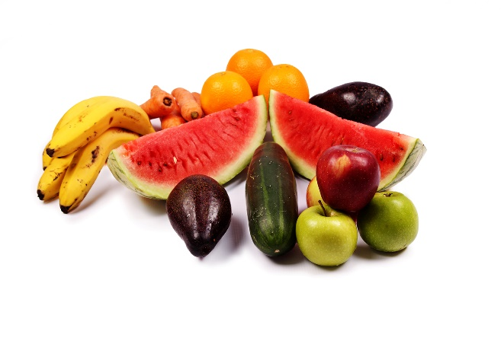
*Storing Fruits and Vegetables- Keep them FRESH!
By storing fruit and vegetables in their proper place, they will stay fresher, taste better, have more health benefits, will last longer, and save money! Here’s a quick guide for fresh produce…

Store these in a dark, dry place:
Hidden from heat and light, these foods can stay fresh for 1-3 months!
Potatoes, Garlic, Sweet Potatoes, Onions, Winter Squash

Let these ripen on the counter; then, eat or move to the refrigerator:
These foods can be kept fresh in the refrigerator for 3-10 days!
Apples, Cherries, Grapes, Melons, Plums, Peaches, Pears, Tomatoes

Store these items in the refrigerator:
Whole, uncut fruits and vegetables can stay fresh uncovered for 3-14 days!
Berries (all types), Beets, Broccoli, Brussels Sprouts, Cabbage, Carrots, Cauliflower, Chile Peppers, Corn, Cucumbers, Eggplant, Green Onions, Green Beans, Leeks, Mushrooms (keep in a paper bag), Okra (keep in a paper bag), Peas, Peppers, Radishes, Summer Squash, Zucchini

Store these items in the refrigerator:
Whole, uncut fruits and vegetables can stay fresh uncovered for 3-14 days!
Keep these items in a sealed plastic bag until ready to use!
Asparagus, Celery, Herbs, Leafy Greens

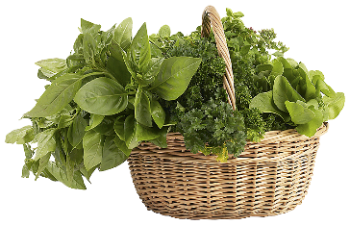
Leafy Greens 1-2-3!
- Buy fresh!
Find greens with crisp, bright, green leaves with no yellow or brown on the ends or stems.
- Store in the refrigerator!
Lettuce and salad greens- Wrap in a paper towel, place in a plastic bag and seal.
Bunched greens with stems (kale, collard greens)- Chop off the end of the stem. Wrap just the end in a damp paper towel and seal in a plastic bag.
Herbs- Do NOT rinse. Wrap entire bunch in a (barely) damp paper towel, place in a plastic bag and seal.
- Wash and enjoy!
Place greens in a bowl and cover with water. Shake greens under the water to loosen any dirt. Allow dirt to settle. Gently pull-out greens and discard water. Repeat as necessary.

This institution is an equal opportunity provider. This material was funded by USDA’s Supplemental Nutrition Assistance Program (SNAP) through the PA Department of Human Services (DHS). Featured information on *Storing Fruits and Vegetables is taken from the SNAP-Ed Funded, New York State Department of Health’s Just Say Yes Curriculum. To learn how you can participate in a SNAP-Ed class via in-person, telephone, or online, please contact Gretchen Billy, SNAP-Ed Project Manager, at (724) 437-6050 Ext. 3281 or email gbilly@fccaa.org.

